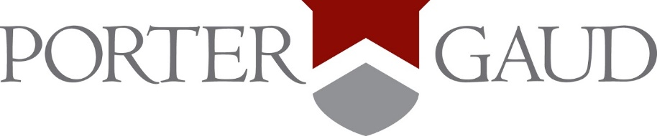

FREQUENTLY NEEDED NAMES AND NUMBERS

UPPER SCHOOL OFFICE
Main Number
(843) 556-3620

Karie Ann Crowther
Administrative Assistant
(843) 402-4709

Brent Hilpert
Upper School Dean
(843) 402-4707

Brad Gilman (through July 1st)
Upper School Head
(843) 402-4838
After July 1st: Sylvia Davis

BUSINESS OFFICE
Margie Stanbrook
Tuition/Billing
(843) 402-4681

ATHLETICS
Larry Salley
Athletic Director
(843) 402-4784

ARTS
Ashley Stock
Director of Performing Arts
(843) 402-4786

COUNSELOR
Fran Ridgell
(843) 402-4824

SERVICE
Gretchen Tate
Director of Community Service
(843) 402-4791

