Positive Peer Relationships and Bullying:

Articles:
Is it Rude, is it Mean or is it Bullying? By Signe Whitson, LSW
https://www.psychologytoday.com/us/blog/passive-aggressive-diaries/201211/is-it-rude-is-it-mean-or-is-it-bullying

Books:
- Best Friends, Worst Enemies by Michael Thompson and Catherine O’Neil-Grace
https://www.amazon.com/Best-Friends-Worst-Enemies-Understanding/dp/034544289X/ref=sr_1_1?ie=UTF8&qid=1538149073&sr=8-1&keywords=best+friends+worst+enemies

- Odd Girl Out by Rachel Simmons
https://www.amazon.com/Odd-Girl-Out-Revised-Updated/dp/0547520190/ref=sr_1_1?ie=UTF8&qid=1538149132&sr=8-1&keywords=odd+girls+out

Discipline with Dignity: How to Build Responsibility, Relationships, and Respect in Your Classroom by Richard L. Curwin , Allen N. Mendler , Brian D. Mendler

https://www.amazon.com/Discipline-Dignity-4th-Responsibility-Relationships/dp/141662581X/ref=sr_1_1?ie=UTF8&qid=1538149343&sr=8-1&keywords=discipline+with+dignity
Organizational Resources:

PACER (Great definitions- see bottom of this document):
http://www.pacer.org/bullying/resources/info-facts.asp

Olweus- Bullying Prevention Program (foundation for our policies- NAIS benchmark program):
https://olweus.sites.clemson.edu/

Restorative Justice:
http://restorativejustice.org/

Videos (shown to all MS students in an assembly):

https://www.pacer.org/bullying/video/player.asp?video=83

https://www.youtube.com/watch?v=KNwM9tgvuiY

https://www.youtube.com/watch?v=GYYSFpFGRBE&index=5&list=PLvzOwE5lWqhScOdC3xMzs9FoAAfpxA-Tz

Bullying Protocol from PG Student Handbook

PORTER-GAUD BULLYING POLICIES AND PROTOCOL

Bullying is unwanted, aggressive behavior among school aged children that involves a real or perceived power imbalance. The behavior is repeated over time. In order to be considered bullying, the behavior must be aggressive and include:

• An Imbalance of Power: Students who bully use their power—such as physical strength, access to embarrassing information, or popularity—to control or harm others. Power imbalances can change over time and in different situations, even if they involve the same people.
• Repetition: Bullying behaviors happen more than once.

Bullying includes actions such as making threats, spreading rumors, attacking someone physically or verbally, and excluding someone from a group on purpose.

Retaliation: Any form of adverse action such as intimidation, reprisal, or harassment directed against a student who reports bullying or who provides information during an investigation of bullying

Prevention: Porter-Gaud students in grades 1-12 receive education on identifying bullying behavior, means of reporting concerns, and bystander education. Students learn to differentiate between rude behavior, mean behavior, and bullying behavior, and how to respond to all three types of conflict.

Reports: Students subject to or who witness bullying are expected to report the matter orally or in writing to the counselor, dean, or head of the respective division. In addition, students who are subject to or witness to retaliation are expected to report the matter.

A parent of a student who is the target of bullying or otherwise has relevant information should promptly notify the counselor, dean, or head of the respective division. Please note the school urges students and parents not to make reports anonymously. Although there are circumstances in which an anonymous report can be better than none at all, it is far more difficult to determine the facts of what occurred if complaints are made anonymously. Students and parents are encouraged to bear in mind that the school takes its policy against retaliation seriously. Also, while the school cannot promise strict confidentiality, because information must be shared in order to conduct an effective investigation, the school releases information concerning complaints of bullying, cyber-bullying, and retaliation only on a legitimate need to know basis.

Responding to a Report:

1. Preliminary Considerations: The school determines what initial steps need to be taken to protect a student’s well-being and the learning environment. Any student identified as a target of bullying will have a meeting with the counselor. Examples of potential protective measures include increased supervision, separation of peers to prevent further bullying or retaliation during an investigation, or notification sent to faculty to be aware of any concerning behaviors.

2. Notification to Parents: The parents of any student who is a potential target and the parents of any student who may have been accused of engaging in bullying behavior will be contacted promptly after a complaint has been made.

3. Investigation: All reports will be studied further, which may include observations and interviews with the person who made the complaint, with the student who may have been the target, with the student against whom the complaint was made, and with any students, faculty, staff, or other persons who may otherwise have relevant information.

4. Resolution, Notification, and Follow up:

· If the allegation of bullying has been substantiated, disciplinary consequences will be assigned. In addition to disciplinary consequences, students may be required to attend counseling. The goal of the process is to correct the situation, avoid repetition of the behavior, and prevent retaliation for reporting.

· Parents of both the target and the student against whom the complaint was made are notified of the findings of the investigation. The Head will comply with applicable laws regarding the disclosure of confidential information when informing students and parents. Please note specific disciplinary consequences will not be shared with the parents of the targeted student. Disciplinary consequences are outlined on page 21.

· The counselor, dean, or head will conduct follow up conversations with students to inquire as to whether there have been any further incidents.

· The Division Head will keep a file on all reports of bullying or retaliation, the investigation, and any actions taken in response to a finding of bullying or retaliation.

PORTER-GAUD CYBERBULLYING POLICY

Porter-Gaud School provides computers and iPads as tools to enhance our students’ education. The school’s computer network and the Internet, whether accessed on campus or off campus, during or after school hours, may not be used for the purpose of harassment of any kind. All forms of harassment over the Internet, commonly referred to as cyberbullying, are unacceptable and viewed as a violation of this policy and Porter-Gaud’s acceptable use policy and procedures.

Malicious use of Porter-Gaud’s computer system is prohibited. Users are responsible for the appropriateness of the material they transmit over the system. Hate mail, harassment, discriminatory remarks, or other associated behaviors are expressly prohibited.

Cyberbullying includes, but is not limited to the following misuses of technology: harassing, teasing, intimidating, threatening, or terrorizing another person by sending or posting inappropriate and/or hurtful e-mail messages, instant messages, text messages, digital pictures or images, or Website postings, including blogs. It is also recognized that the author (poster or sender) of the inappropriate material is often disguised (logged on) as someone else.

In situations in which the cyberbullying originated from a non-school computer or device, on campus or off campus, and brought to the attention of school officials, any disciplinary action shall be based upon whether the conduct is determined to be disruptive of the educational process so that it markedly interrupts or severely impedes the day-to-day operations of the school.

Disciplinary action may include: the loss of computer privileges, administrative detention, suspension, or expulsion for verified perpetrators of cyberbullying.

DISCIPLINARY PROCEDURES
Discipline is considered a part of the growth process and basic to the development of character. Students should understand the need for rules, the part they play in maintaining order, and the necessity of observing rules. The responsibility for implementing the behavior expectations in Middle School has been delegated to the Middle School teachers, staff members, the Dean of Middle School, and Head of Middle School.

Teachers assign classroom detentions for infractions of classroom procedures. If these teacher detentions do not prove effective in producing desirable results, the teacher should request a conference involving the student’s advisor, parents, the teacher, and the Head of Middle School.

Advisors distribute notification of Administrative Detentions. These notices require a parent signature and are expected to be returned to the Middle School Dean. The following are procedures to help students grow in self-discipline and personal conduct. These are possibilities of punishments, and do not have to occur in any particular order, depending upon the seriousness of the behavior. Some consequences may be combined as one punishment.

POSSIBLE CONSEQUENCES
-Verbal Warning

- Detention served for a classroom teacher or an Administrative Detention with the Dean of Middle School. Classroom detention is served at the discretion of the teacher. Administrative detention is served throughout the day combining community life and recess, as well as potentially after school from 3:15 – 3:45. NOTE: A warning does not have to precede a detention. Lateness to detention or failure to report for a detention leads to a student serving two consecutive detentions. A missed detention because of an excused absence is made up the next scheduled detention day. Excessive detentions may lead to re-enrollment being withheld for the next school year, suspension, or expulsion from school.

- Restorative Justice- based on the violations of the students that prompt an administrative detention, a student may also receive a reflective assignment and or restorative objective if a relationship between student and teacher, or student and student was damaged. These reflective assignments are intended to correct behavior through reflection and action.

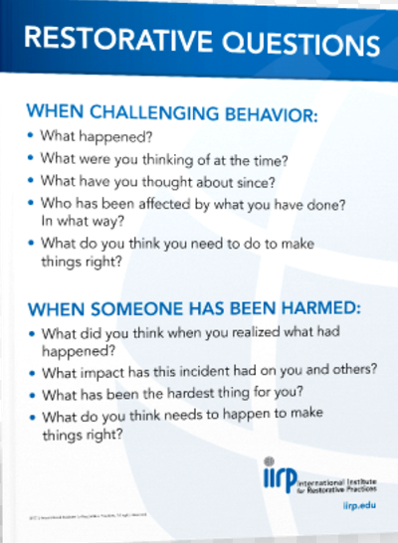

- Mandatory Parent/Head of Middle School/Dean /Teacher Conference to discuss behavior problems and consequences if a student’s pattern of behavior is not changed.

- Suspension is assigned for major violations of School rules. A student whose actions result in suspension has violated the trust of the School community and is consequently separated from the community, serving the suspension out of school. Students who miss School work because of suspensions are expected to make up that work as soon as possible at a time convenient for their teachers (students should be in contact with their teachers in the case of a multi-day suspension.) Students will receive a one point deduction in each class during the marking period when the suspension occurs. An exception is a major cumulative project (such as a semester paper), which qualifies for full credit if submitted on the date due. Students should also expect additional consequences from extracurricular organizations.

Students suspended from school will not be readmitted to school until an administrative conference is held with the student and parents. All work missed while suspended must be made up. A student has as many days as he/she was suspended in order to complete make-up work. During the period of suspension, the student may not be on campus, may not attend classes, off-campus school activities and on or off-campus athletic practices or games.

Disciplinary Warning- Disciplinary Warning is designed to inform the student and his/her parents that a student appears to be making decisions which are leading the student in a direction which is opposed to the School’s mission and which are of concern to the faculty. The student and parents are notified and invited to a meeting with the Dean and the Middle School Head to discuss those concerns. Any disciplinary penalty accompanying Disciplinary Warning is at the discretion of the Dean or the Middle School Head. Warning status is temporary, and the student’s behavior and progress are reviewed by the Dean or the Middle School Head regularly for improvement. Failure to improve behavior can lead to probationary status.

Disciplinary Probation- Disciplinary Probation is the means whereby the student, parent, teachers, Dean and the Middle School Head are all advised that a serious behavior problem has developed -- one that bears scrutiny on a day-by-day basis. A student is assigned Probation by the Middle School Head, usually after consultation with the faculty and/or administration. The details and duration of the Probation are explained in conference with the student and parents and in a letter. A student on Probation must return to good standing or face withdrawal from the School. Probation may be assigned at any time for a portion of a semester, a semester, an entire school year, or longer.

Expulsion- Expulsion is the final and most serious disciplinary consequence, and may be applied to the most serious or chronic violations of School rules and expectations. Depending upon the nature of the offense and the severity of the consequences, a report of a serious disciplinary incident may go in a student’s permanent file.

Head of School’s Committee of Review -The Committee of Review serves as an advisory group to consider cases involving a student’s potential expulsion. The Committee includes the Heads of the Lower, Middle and Upper Schools, the Dean, the Faculty Representative to the Head of School’s Council and the student’s faculty advisor. The appropriate division Head chairs the Committee. The Committee meets and reports to the Head of School, who makes the final decision about disciplinary consequences for the case in question.

In any case involving expulsion, the Head of School’s decision is final.
Disciplinary Consequences (Olweus)

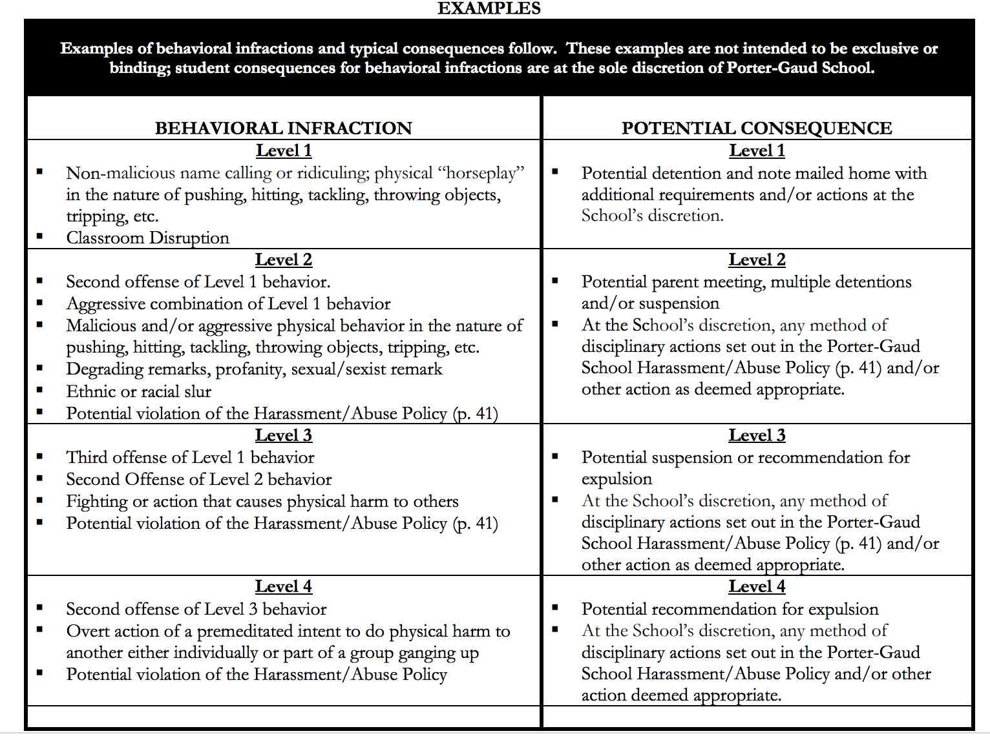

IMPORTANT DEFINTIONS FROM NATIONAL BULLYING PREVENTION CENTER (Pacer)

